PARISH NEWS
The Deverills & Crockerton
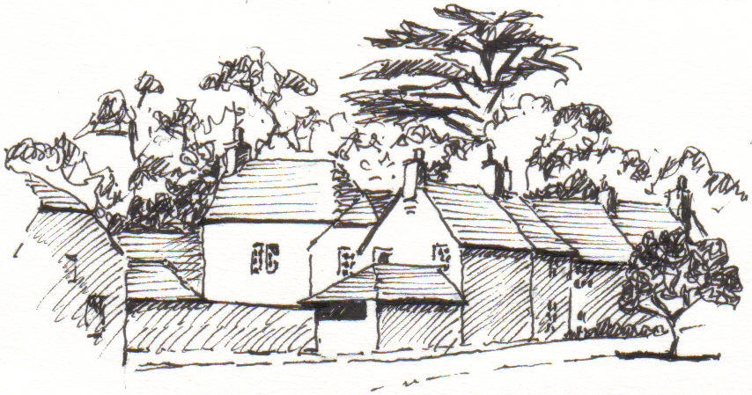

The Old House, Longbridge Deverill
by Pat Armstrong

March 2009

Look inside for local information

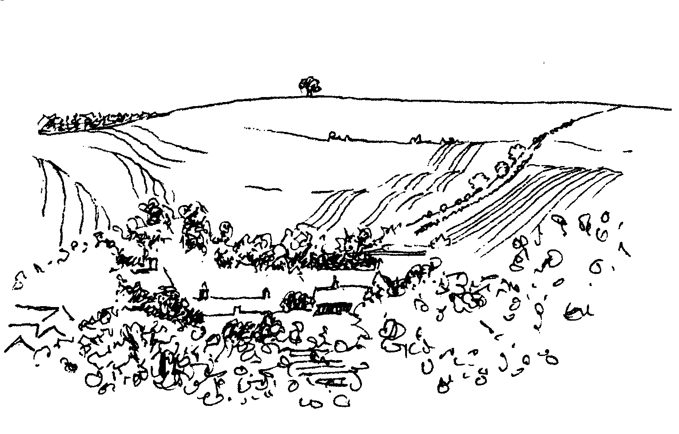
-2-
PARISH OF THE DEVERILLS AND HORNINGSHAM

LENT LUNCHES
Friday 6th March 12.00 noon – 2.00 pm
At Longbridge Deverill Village Hall
*Friday 13th March 12.00 noon – 2.00 pm
At Kingston Deverill Village Hall
Tuesday 17th March 12.00 noon – 2.00 pm
At 212 Pottle Street, Horningsham
(the home of Richard and Jane Yates)
Friday 27th March 12.00 noon – 2.00 pm
At Longbridge Deverill Village Hall
Do join us for a light lunch each week during March.
Proceeds will be given to Juba Secondary School, Sudan
Fairtrade Fortnight is from 23rd February to 8th March,
some of the ingredients used for the Lent lunches will be Fairtrade
*Friday 13th March will be an opportunity to find out more about Fairtrade
and purchase Fairtrade goods
Annual Parochial Church Meeting
Sunday 19th April
After the Evening Service at 5.30 pm in Longbridge Deverill church the meeting will take place at 6.00 pm in the village hall
Refreshments will be served at approximately 7.00 pm
Copies of the previous minutes will be posted on each church
notice board beforehand

Coffee, Cards and Chat
Come and enjoy looking at the new range of cards,
ribbons, wrapping paper, and other exciting items
displayed by John and Maddie Goodden
in the Upper Deverills Village Hall on Thursday 19th February
between 10.30 and 12.00 noon - everyone is welcome
Donations will be made to the hall and the church

Friends of Heytesbury, Knook & Tytherington Churches
A talk with supper in Sutton Veny village hall in aid of the churches
Thursday 19th March - Ancient Treasures & New Inventions
The doors open at 6.30 pm talks to begin at 7.00 pm prompt
Tickets £15.00 for talk & supper, please contact
Jane Howard-Vyse, 74 High Street, Heytesbury BA12 OEB (840258) or
Annie Charlesworth, 57 H
Cheques payable to The Friends of HK&T Churches

-3-


From your Rector
Have you ever had a ‘chance’ conversation that has set you thinking and led to a new perspective (or reminded you of an old one!)?
In recent days, I have had at least two such encounters. The first conversation began with comments about the February snowfall. Having talked about the beauty of the countryside with its covering of snow, the conversation moved on to the opportunities that the snow brought. For many, it was too dangerous to venture in to work or school. The result? Time at home with the family. Playing in the snow! Sledging! Building a snowman! Watching a DVD received at Christmas! Sitting by a warming fire! Dare I say – conversation with everyone able to join in!
‘It was so good to spend time together,’ was the comment I heard. ‘I wish we could do it more often. There was less traffic, less rush, more enjoyment in the ordinary, everyday things. We just had to make do.’
The second conversation was less comfortable. It concerned worries over a serious financial issue, brought about by the current uncertainty in the world of finance. What can we say to those we know who may have made a decision in good faith? If due consideration has been given to the facts as we know them, we might be forgiven for expecting all to be well. But when everything goes topsy-turvy, the benefit of hindsight only serves to undermine earlier decisions however carefully (and prayerfully) they were made.
Where your heart is, there your treasure will also be (Matthew 6:21)
Challenging words! Where is your true treasure?
The season of Lent has just begun. It gives an opportunity to take stock, to ‘count our blessings’, to engage with our communities and to decide exactly where our priorities lie. Come and share in a Lent lunch, a discussion group or talk, a quiet morning. Give yourself time to ponder the new perspectives waiting on the horizon.
May your Lenten journey be fruitful.
Norma Payne
Lent Talks in the Benefice
Thursday 12th March 7.30 pm at St Margaret's, Corsley
Steven Baggs, Church Army officer, ‘Engaging with young people & communities’ Thursday 19th March 7.30 pm at Chapmanslade School Hall
Rev Diane Whittall, Chaplain at Erlestoke prison - ‘Engaging with the community’
Thursday 26th March 10.00 am to noon at St Peter & St Paul Longbridge Deverill
Quiet Morning for Lent
Lent Talks in Salisbury Cathedral - ‘Fully Alive’
May I remind you of the talks by Timothy Ratcliffe Wednesdays at 1.00 pm in the Cathedral on 4th, 11th, 18th, and 25th March with a final address on Wednesday 1st April at 7.30 pm. I do recommend to you these talks, his message is constantly fresh, and his book on the Eucharist is the Archbishop of Canterbury’s book for Lent. This is an opportunity for car sharing and valuable discussion time on the journey home afterwards.

-4-

Annual Revision of Church Electoral Roll
As in previous years the PCC of the Deverills is required to conduct an annual revision of the Church Electoral Roll in the spring. This revision must be completed in time for the Annual Parochial Church Meeting that will take place on Sunday 19th April 2009. The period of the revision closes on Saturday 28th March; a notice to this effect will be displayed on the notice board in each of our churches.
Please will Parishioners let me know of anyone whose name they think should be removed from the Roll (with a reason please, eg. deceased, moved abroad, etc.), as an aid there is a copy of the current Electoral Roll on the Notice Board of each church. Blank Electoral Roll registration forms will be placed at the back of each church for completion by anyone in the Parish whose name is not on the current Roll but who now wishes to be included. Please send the completed forms to me, or hand them to a Church Warden. Could I also ask that on the forms you include in addition your telephone number and the name by which you wish to be known.

Mike Tulloch - Parish Electoral Roll Officer
Francesca Elloway in the Democratic Republic Congo
The day Francesca, our mission partner working for the Church Mission Society, returned to Aru she went to the funeral of the Archdeacon's son. Tragically he was killed by a falling tree in high winds. For the first six weeks she was rather tied to the office before she was able to go on visits to the health centres. The Diocese had been asked to take over the responsibility for the Mahagi centre. This means it must have the infrastructure and staff to become a hospital. Thanks to the staff and the head nurse in charge this is possible. Aru and Mahagi are now able to give treatment to prevent the transmission of HIV from mother to child. There is also a mobile clinic. The health centres at Adanga and Obani now flourish. Ekanga has personality problems within the staff and needs our prayers. In the north Kumari thrives but Kima has problems with the local community. We are asked by Francesca to pray for the health centres and for a resolution of the problems both north on the Sudanese border and south in the Goma area, where the population is suffering appallingly. A copy of her letter is in each church.
Elisabeth Atkinson
Longbridge Deverill Bells
Sadly, the family from Kingston Deverill who rang the bells at Longbridge Deverill have had to give up. There are eight bells in St Peter and St Paul’s tower and it needs a minimum of four, preferably six or even eight, people to ring them. It is so sad to have bells that are in good order now silent. It may be possible for weddings to get ringers from other churches. But PLEASE are there any people willing to try their hand at ringing. If you are interested and want to know more please contact the churchwardens or Stephen Young whose telephone numbers are on the back of the Parish News.
Elisabeth Atkinson

-5-
Upper Deverill Parish Council
Broadband Working Party Questionnaire
Last month’s Parish News enclosed a questionnaire asking people’s views about the provision of Broadband in the Upper Deverills. We have received several completed copies but there are many internet users in Kingston, Monkton and Brixton who may still like to send one in. Please call one of the following for a copy and we will pop one in to you: Albert Lee 844759; Robin Greenwood 840743; Richard Munro 844385.
Frome Community Hospital
Enos Way, Frome, BA11 2FH Tel: 01373 454740
Minor Injury Unit (MIU) opening times: 8:00 am to 6:00 pm
Minor injuries and urgent health problems can occur at the most inconvenient times. Minor Injury Units are a modern and fast way to deliver high quality care to patients with a minor injury and illness. MIUs are staffed by Emergency Nurse Practitioners, who have the training and experience to deal with more than just the regular cuts, bruises and sprains. They are nurse specialists with extensive nursing practice based in all aspects of Accident and Emergency (A&E) nursing as well as additional skills, such as health promotion. They also fulfil some functions which were historically performed by doctors.
What can and cannot be treated
Minor Injury Unit staff can:
- stitch cuts
- remove foreign bodies from ears, noses etc,
- remove splinters
- dress minor wounds, cuts and grazes
- apply plaster casts
- provide screening and treatment for Chlamydia
and treat
- sprains and strains
- minor broken bones
- minor burns and scalds
- minor head injuries
- insect and animal bites
- minor eye injuries, and other minor injuries
Minor Injury Units cannot treat:
- unconscious patients
- serious medical conditions
- major injuries
- overdoses
- alcohol related problems, or mental health problems
In such cases an Ambulance should be called by dialling 999

-6-
Deverill Valley & Crockerton Women's Institute
Longbridge Deverill Hall - Monday 9th March 7.30 pm
Annual Meeting and Social time
with board games and supper
For more information contact Ann Dufosee 840360

CROCKERTON VILLAGE COMMITTEE
Present the Village Quiz Night
Sunday 8th March at The Bath Arms
7.00 pm for 7.30 pm
£8.50 a ticket to include a main meal
£1 of each ticket kindly donated by Dean to Crockerton School
To book contact: Marion 213739, Tracey 216939, Bernie 218401
Teams of four please – everyone is welcome

Salisbury Theatre Club Trips
Monday 9th March
The Real Thing by Tom Stoppard
Monday 20th April
Restoration by Rose Tremain
Monday 18th May
The Importance of Being Earnest by Oscar Wilde
The cost is £17.00: theatre seat £12.00 and coach trip £5.00
Booking and payment in advance to Mary Stewart Cox Tel 840877
Longmead, Brixton Deverill, Warminster BA12 7EJ
Coach leaves Kingston Church 6.10 pm collects through the Deverills
Performances begin at 7.30 pm

Longbridge Deverill Village Hall
Talk and film by Guy Hagg
‘Tagging sharks in Mexico’
Wednesday 25th March 7.30 pm
Tickets £5.00 and includes a Ploughman’s supper
Bring your own wine - tickets on the door
-7-
Upper Deverills Village Hall
Indian Curry Night Saturday 18th April
Please note this date in your diaries. We will serve an excellent range of curries and accompaniments, more details in April’s Parish News.
Upper Deverills Village Hall Kitchen
Things have moved slowly this month regarding the village hall kitchen. The committee meetings have been cancelled due to the very bad weather. This means no formal applications for funding have been made as yet. We have been very fortunate in the response to the appeal for a hostess trolley and have also the promise of a microwave which will be great. We will be thanking those folk who answered our appeals in due course. Picking these items up has been a problem due to the weather and Phil’s unsocial hours policing shifts so I would like to thank those concerned for their patience.
The response to the idea of a village cookbook has not been so good; only two people responded. I thought as this is a project to involve the whole of the community, young and old, there would be more enthusiasm. It brings me to the question, “Are we expecting too much now of village participation?” Is it a sign of the times that we have no time to enjoy village life as it was in the past? I do hope not. So let us have another crack at this cook book and all leave our mark helping to fund this kitchen project for ourselves and those to come. Please post any recipes to Dizzy at Longbarrow, Kingston Deverill BA12 7HF.
Dizzy Bridge 845166
Longbridge Deverill Village Hall
‘Tagging Sharks in Mexico’ talk & film - Wednesday 25th March at 7.30 pm
Guy Hagg will give a talk and show a film about his experiences as part of a research programme in Mexico, ‘tagging’ the great white, scalloped and hammer head sharks. Tickets will be £5.00 and will include a ploughman’s supper. Please pay at the door. Bring you own wine etc.
Annual General Meeting - Wednesday 15th April at 7.00 pm
AGM and appointment of the hall committee, all members of the public are very welcome to attend and contribute to the meeting.
Sunday 26th April - St George's Day lunch
May/June - Open Gardens
October - John's Local Talent Music Night
Jo Nelson - chairman
The Deverills Cricket Club
The Deverills Cricket Club will be warming up for the new season with some nets sessions in the indoor nets at Warminster Cricket Club. Details are as follows:
Sunday 29th March 4.00 - 5.00 pm
Sunday 5th April 4.00 - 5.00 pm
Sunday 19th April 4.00 - 6.00 pm (yes, 4.00 - 6.00 pm)
All are welcome.
Jamie Fagan 07796 698180

-8-

SERVICES PARISH OF DEVERILLS & HORNINGSHAM

Sunday Lent 1
1st March Brixton 8.00 am Holy Communion 1662
Longbridge 10.30 am Holy Communion
Horningsham 5.30 pm Evensong

Sunday Lent 2
8th March Kingston 10.30 am Holy Communion
Horningsham 11.15 am Holy Communion

Sunday Lent 3
15th March Longbridge 8.00 am Holy Communion 1662
Brixton 10.30 am Holy Communion

Sunday Mothering Sunday
22nd March Longbridge 10.30 am Mothering Sunday Service
Horningsham 11.15 am Mothering Sunday Service
Kingston 6.00 pm Evening Prayer

*Sunday Passion Sunday
29th March Corsley 10.30 am Benefice Service

Sunday Palm Sunday
5th April Kingston 8.00 am Holy Communion 1662
Longbridge 10.30 am Morning Worship
Horningsham 6.30 pm Evensong

Tuesday, Wednesday, Thursday, Friday
Longbridge 8.30 am Morning Prayer
Wednesday
Longbridge 10.15 am Holy Communion

*NB: SUNDAY 29TH MARCH CLOCKS GO FORWARD ONE HOUR

The Deverills & Horningsham Register
Funeral
Betty Jean Kukowka at Longbridge Deverill on Tuesday 17th February

-9-
SERVICES PARISH OF CORSLEY & CHAPMANSLADE

Ivy House St Denys Retreat Centre
A place for rest, refreshment and renewal

Friday 6th March - House Quiet Day
‘With God in the Wilderness’
with the Venerable Alan Jeans

Friday 27th March - CSD Gathering Day
A quiet day of guided reflection open to all

Cost: £16.00 including coffee, lunch and tea
For more information please phone 214824
Sunday Lent 1
1st March Corsley 9.00 am Holy Communion

Sunday Lent 2
8th March Chapmanslade 9.00 am Holy Communion
Temple 11.00 am Morning Prayer

Sunday Lent 3
15th March Chapmanslade 9.00 am Holy Communion
Corsley 6.00 pm Evening Worship

Sunday Mothering Sunday
22nd March Temple 9.00 am Holy Communion 1662
Corsley 10.30 am Mothering Sunday Service

*Sunday Passion Sunday
29th March Corsley 10.30 am Benefice Service

Sunday Palm Sunday
5th April Corsley 9.00 am Holy Communion

*NB: SUNDAY 29TH MARCH CLOCKS GO FORWARD ONE HOUR

-10-

Church Cleaners for February
Kingston – Mrs Beilby & Mrs Noonan
Brixton - Mrs Huntley & Mrs MacDonald
Longbridge - Monday 2nd March 9.30 - 10.30 am - all helpers
Church Flower Arrangers for February
 | Kingston | Brixton | Longbridge
1st March | Lent No Flowers
8th March | “
15th March | “
22nd March | Mothering Sunday posies please
29th March | Lent no flowers

CONTACT THE EDITOR AND WEBSITE
Parish News Editor - Judy Munro 844385
Contributions for the Parish News through my letterbox or
by post to Whitepits Lodge, Kingston Deverill, Warminster,
BA12 7HD or by Email: judymunro@tiscali.co.uk Thank you
Please remember the deadline is the 15th of every month

Website: www.deverills.org.uk Email address:info@deverills.org.uk
Website manager : Kate Wilkinson 844998
Contents: Parish News with church services, Parish Register, Events, Local News plus pictures and other information
Contact the Clergy
Please contact Norma Payne (841321) or Di Britten (01373 832515) if anyone is housebound and would like communion or a visit at home; or if someone is ill and needs our prayers; or to discuss any church matter.
Office administrator phone 210149 or email: office@cleyhill-team.org.uk

-11-

Crockerton School News
We have two pieces of exciting news for you in this edition of the Parish News.
The first is regarding our Headteacher. I’m pleased to say that we have just appointed our Headteacher following a rigorous interview process which culminated in an interview day which was held on Friday 13th February. As many of you will know, when Val Culff left the school, Carol Clough was appointed as Acting Headteacher. Carol has done great work with the school, not only in taking it forward, but also in establishing her own ‘presence’ at the school. I’m very pleased to advise that we have offered Carol the role on a permanent basis and the Board of Governors look forward to continuing to work with Carol.
Our second bit of news is regarding the Mobile Classroom project. As some of you will already be aware, we are going to be replacing the existing mobile classroom with a newer one later in the year. As we said in the February Parish News, planning permission has already been granted for this and the governors are currently looking at the best way to undertake the project. The double mobile which is going to replace the old single mobile was originally sited at Archbishop Wake School in Blandford and is one of a number that have gone to various schools in the county. The haulage contractors who will bring it into place for us are currently storing it for us near Blandford. They will then transport it and ‘crane’ it into place after the necessary ground works have been completed.
The mobile classroom is going to be sited in the same place as the old one but due to it being slightly bigger some of the area between the school and the existing mobile will be used. The new mobile will give us two classrooms, two toilets (one of which will be disabled access) and a small lobby area for coats etc. To keep the space as flexible as possible the two classrooms will be divided by a retractable partition allowing the area to be opened up easily into one large space when we need to undertake things such as school plays, or whole school acts of worship. During the works, we will also be taking the opportunity to increase some of the parking on site, thus reducing the number of cars parked on the road; we are hoping to be able to accommodate up to five cars in the new parking area.
We are still working on further details of the mobile classroom, as to when we want to start work and when we expect it to be completed. We hope to be able to tell you more, and maybe show you some pictures, in the next edition of the Governor Newsletter, which will be distributed with the Parish News at the beginning of April. In the meantime, if you have any questions, please don’t hesitate to contact me.
Crockerton Forum
An ‘Open’ forum meeting was held on 27th January at the Bath Arms. It was well attended with a good amount of lively discussion about the playing field, new projects at the school and parking / traffic. Full minutes of the meeting (and those from previous meetings) are available on the website at: www.deverills.org.uk or from members of the committee. If any of the residents wish to volunteer to help with the morning ‘stop and drop’ system please contact me direct by phone.
Graham Dopheide - Chair of Governors - 07894 546477

-12-
Where have you been?
Thermae Bath Spa - Antidote to winter
Why would you want to swim out of doors in the winter? That was my reaction when I was given a voucher for the Thermae Bath Spa reopened quite recently in Bath. When I finally made it there on a sunny but cold and windy day last March I enjoyed it more than I would have believed possible. The water in the rooftop pool is so warm you relax completely and can float while gazing out at the Bath vistas and green hills behind. Every so often the pool goes into Jacuzzi mode with an invigorating bubble massage. A quick dash in the open air and you are back indoors in the warm again.
The Spa has delights on every floor – four steam rooms of increasing heat with individual footbaths on the second floor. Below these are individual treatment rooms for massages or facials, which cost extra and can be prebooked. There is also a nice café with snacks and drinks - hot and cold, hard and soft - and another big pool in the basement with hot water baths.
For treatments, they provide a robe, slippers and towels. Otherwise these can be hired. The changing rooms are sumptuous and high tech with showers and hair dryers. I emerged feeling totally regenerated. If possible avoid weekends and school holidays - although there is plenty of space, it’s nicer not to be too crowded. For £22 you get two hours, or 4 hours for £32, and a generous amount of time to change.
This month’s contribution has been sent in by Judith Mirzoeff from Kingston Deverill. I must say she does make the spa sound very appealing! I would be very grateful for any other contributions - it makes such a difference to get another person’s perspective. Please send your comments and suggestions to me by email at farthings.kd@btinternet.com or into my letter box at Farthings, Kingston Deverill.
Trish Shuler
Recipe of the Month - Lemon or Orange Drizzle Cake
Ingredients Topping:
110 grams (4 oz) butter or margarine One lemon or one orange
175 grams (6 oz) caster sugar 3 tablespoons lemon or orange juice
2 eggs 3 tablespoons caster sugar
175 grams (6oz) self raising flour
1 - 2 tablespoons milk
Method
Cream butter/margarine and sugar, gradually add beaten eggs, sifted flour, milk and grated rind from the lemon or orange. Beat well. Put into a 2 lb loaf tin which has been greased and lined. Bake at 180ºC or 350º F for approximately 45 minutes. Do not take cake out of the tin. Pour over the juice and sprinkle with caster sugar. Leave to cool before turning out. Enjoy as a dessert with crème fraiche, cream or for afternoon tea.
Come and see the full range of groceries we have in the shop; we are also licensed and agents for dry cleaning.
Sponsored by Maiden Bradley Community Shop (844206)

-13-
Nature Notes
The days are definitely drawing out now and when the sun shines it begins to feel like spring. I wake in the morning to a song thrush singing and this evening he was singing again. Hares are increasing in numbers in the fields; I counted ten in one field this evening and I had already seen three previously in another field. Other birds are singing too. I’ve heard great tit calling and dunnock and tree sparrow. The robin continues to sing but now the song is more cheerful than the melancholy winter air. I heard a great spotted woodpecker drumming the other day up in the wood above the farm, and this morning I was sure I heard the laughing call of a green woodpecker. The nuthatches in the garden are very active and vocal, calling to each other, and still appear to be storing food. We will have sunflowers growing all over the show!
There are still remnants of the snow that we had over a week ago in the sheltered shadow areas where the sun hasn’t been able to get, even after all the cold rain that has fallen since. It just goes to show how cold the ground has been. I had some lovely walks in the snow and found lots of footprints of deer, fox, hare and badger. I had had no idea how busy the fields were with animals moving along ‘super highways’. It was lovely to see the hares and deer in the snow, just like Christmas card scenes. One day after the first snowfall I counted a dozen hares on the fields opposite, they seemed to be playing in the snow and stood out so clearly, as did the three deer that were trying to ‘graze’ on the slopes of the hill. When walking up at the top of the farm I became aware of dark shapes in the snow, at first I thought they were bits of tree blown down but, when I went to investigate I realized they were hares sitting tight in their ‘forms’ which had now become snow holes! As I approached one, the poor hare shot off across the white field of snow leaving a lovely clear set of footprints and me feeling guilty for having disturbed it.
Winter takes its casualties. Small animals and birds are at the greatest risk, they have such a high metabolic rate and need to take in enough food to fuel such a life. This becomes more difficult in bad weather. One of ‘our’ wrens didn’t make it into the safety of the house martin nests for the night during the week of snow and I found it dead on the patio in the morning. A tawny owl was found on the side of the lane in Brixton Deverill, one very wet and windy night back in January, emaciated, weak and only just alive. Sadly it died very soon after being found. Wind and rain are no good for hunting if you are a bird of prey.
I have had two great surprise sightings recently. On the 25th of January I saw a red kite flying over our farm buildings, I was putting my bike away and glanced skywards and saw what I assumed was a buzzard only to realize a second later that it had a longer tail and that was it was forked and much redder in colour! Then on 11th February walking up the track at the back of the farm as it was getting to dusk, I saw something fly low. It was very obviously white/cream in colour - a barn owl! I watched it as it flew low over the ground carefully looking for any small mammals that moved. I kept very still and quiet, I don’t think it knew I was there, as it flew closer to me. I had fantastic views through the binoculars. I’ve been back to look for it again in the late evening but so far without success.
Jane Trollope (written on 14th February)

-14-

LOCAL COUNCILS, SOCIETIES, GROUPS etc.
Longbridge and Crockerton Parish Council
Karen Manfield 215526 (Chair) Peter Whithey 840347 (Vice Chair)
Helen Few 840119 (Clerk) Thomas Minter 216909
Bill Hurd 840023 Elaine Pidgeon 212878
Julian Algar 840816 Graham Read 840296
Brian Marshall 214789
Upper Deverills Parish Council
Lady Felicity Wheeler 844683 (Chair) Ranald Blue 841374
Jacqueline Smith 840238 (Clerk) Patricia Shuler 844291
Sarah Fagan 844123 Robin Greenwood 840743
District Councillor
Shear Water Ward - Michael Mounde 844363

Longbridge Deverill Village Hall Committee
Jo Nelson 840784 (Chair)
Barbara Smith 840251 (Secretary) Sylvia Titt 214825 (Caretaker)

Upper Deverills Village Hall
Richard Cousens 844970 (Chair)
Mandy Martyn 844320 (Secretary) John Lea 844325 (Hall bookings)

Crockerton Millennium Committee
Marion Thomas 213739 (Chair)

Pre-School Children and Parents ‘Thursday Group’
Barbara Beilby 844995 (Chair) Sylvia Titt 214825 (Leader)

Deverill Valley & Crockerton W I
Ruth Sutton (President) Jill Russell 840209 (Secretary)

Sir James Thynne Almshouse
Mrs Sue Jackson 840322 (Steward)

Deverills Cricket Club
Jamie Fagan 844123 Peter Child 01963 34593

Wylye Valley Tennis Club
Colin Singer 213696

Wylye Valley Flower Club
Mrs Hazel Yate 215617 (President) Mrs S Scott 213689 (Programme Secretary)

Wiltshire Wildlife Trust
Elm Tree Court, Long Street, Devizes SN10 1NJ www.wiltshirewildlife.org

Rural Community Beat Officer - Police Community Support Officer
PC Phil Bridge - PCSO Ian Owen - 0845 408 7000

Hospital Transport Link Scheme 211655

-15-

F O R T H C O M I N G E V E N T S
Forthcoming Events

F O R T H C O M I N G E V E N T S
F O R T H C O M I N G E V E N T S
- Hearing Loss Lip-reading Wednesdays Margaret Head (213259)
- Scottish Dancing Monday Evenings Aline Fry (841054)
- Badminton Mondays & Fridays 3.00 - 5.00 pm Alison Rymell (844819)
- Pre-school & Parents Group Thursdays 10.00 - 11.30 am See p14
- Fairtrade Fortnight 23rd February to 8th March See p2
- Longbridge & Crockerton Parish Council meeting 7.30 pm Monday 2nd March at Longbridge Village Hall See 14
- Fully Alive talks 4th, 11th, 18th, 25th March & 1st April See p3
- Lent Lunch at Longbridge Deverill Friday 6th March See p2
- Ivy House Quiet Day Friday 6th March See p9
- Crockerton Quiz Night Sunday 8th March See p6
- Women’s Institute Annual Meeting Monday 9th March See p6
- Salisbury Theatre Club Monday 9th March See p6
- Wylye Valley Flower Club ‘Just for you’ Tuesday 10th March See p14
- Upper Deverills Parish Council meeting 7.30 pm Wednesday 11th March at the Upper Deverills Village Hall See p14
- Lent Talk Thursday 12th March See p3
- Lent Lunch at Kingston Deverill Friday 13th March See p2
- Lent Lunch at Horningsham Tuesday 17th March See p2
- Lent Talk Thursday 19th March See p3
- Sutton Veny Village Hall Talk Thursday 19th March See p2
- Talk & film ‘Tagging Sharks in Mexico’ Wednesday 25th March See p6/7
- Lent Quiet Morning Thursday 26th March See p3
- Lent Lunch at Longbridge Deverill Friday 27th March See p2
- Ivy House CSD Gathering Day Friday 27th March See p9
- Deverills Cricket Club Nets Sunday 29th March See p7
- Deverills Cricket Club Nets Sunday 5th April See p7
- Longbridge Deverill Village Hall AGM Wednesday 15th April See p7
- Indian Curry Night Saturday 18th April See p7
- Deverills Cricket Club Nets Sunday 19th April See p7
- Annual Parochial Church Meeting Sunday 19th April See p2
- Salisbury Theatre Club Monday 20th April See p6
- St George's Day lunch Sunday 26th April See p7
16-
PARISH OF THE DEVERILLS AND HORNINGSHAM
Churches
SS Peter & Paul the Apostles Longbridge Deverill (LD)
St Michael the Archangel Brixton Deverill (BD)
St Mary the Virgin Kingston Deverill (KD)
St John the Baptist Horningsham (H)
Rector
Rev Norma Payne, 6 Homefields, Longbridge Deverill 841321
Clergy
Rev Diana Britten, 69 Lane End, Corsley 01373 832515
Licensed Lay Ministers
Mr John Budgen, Woodlands, Sutton End, Crockerton 218203
Col Robin Chappell, 7 Elm Hill, Warminster 212153
Churchwardens
Mrs Elisabeth Atkinson, 133 Foxholes, Crockerton (LD) 212129
Mr Nigel Poole, 7 Homefields, Longbridge Deverill (LD) 840902
Mrs Mary Stewart Cox, Longmead, Brixton Deverill (BD) 840877
Major Mike Tulloch, Spring Cottage, Monkton Deverill (KD) 844381
Mr Tim Moore, Manor House, Church Lane, Horningsham (H) 844336
Lay Pastoral Assistant Co-ordinator
Rev Norma Payne, 6 Homefields, Longbridge Deverill 84l321
PCC Treasurer
Mr David Stratton, Manor Farm, Kingston Deverill 844549
PCC Secretary
Mrs Anne Honley, Dry Hill House, Crockerton 215956
Church Electoral Roll Officer
Major Mike Tulloch, Spring Cottage, Monkton Deverill 844381
Parish News Editor
Mrs Judy Munro, Whitepits Lodge, Kingston Deverill 844385
Organist
Mr John Budgen, Woodlands, Sutton End, Crockerton 218203
Tower Captain
Mr Stephen Young, 68 Highbury Park, Warminster 212796
Caretaker - Longbridge Church
Mrs Sylvia Titt, 7 Church Street, Longbridge Deverill 214825
Office Administrator (Mon -Thurs 10.00 - 12.00)
Mr Dick Collins, 22 Church Street, Warminster 210149

